INSPIRE

Infrastructure for Spatial Information in Europe

Member State Report:

Malta 2010

Title | Malta 2010
Creator | Malta Information Technology Agency
Date | August 2010
Subject | INSPIRE Monitoring and Reporting
Status | V 1.0
Publisher | Malta Information Technology Agency
Type | Text
Description | A report on Malta’s progress in the implmentation of the INSPIRE Directive
Contributor | Malta Information Technology Agency

Format

Source
Rights | Public
Identifier | INSPIRE REPORT BY MALTA 2010
Language | EN
Relation | NA
Coverage | NA

These are Dublin Core metadata elements. See for more details and examples http://www.dublincore.org/

Version number | Date | Modified by | Comments
1.0 | 10 May 2010 | Matthew Gatt | Draft
1.1 | 31 August 2010 | Matthew Gatt | Final

Abbreviations and Acronyms

INSPIRE / Directive Directive 2007/2/EC
MEPA Malta Environment and Planning Authority
MITA Malta Information Technology Agency
MS Member State
MT Malta
SDI Spatial Data Infrastructure

Table of Contents

1 Executive Summary 3
2 Introduction 4
3 Co-ordination and quality assurance (Art. 12) 5
4 Functioning and coordination of the infrastructure (Art.13) 8
5 Usage of the infrastructure for spatial information (Art.14) 10
6 Data sharing arrangements (Art.15) 11
7 Conclusions 12
8 Annexes 13

Executive Summary
The first INSPIRE monitoring report outlines the progress in implementing the Directive by Malta. The Directive has been transposed into Maltese Legislation under the provisions of the Development Planning Act and brought into force by Legal Notice on the 22nd December 2009.

The Malta Information Technology Agency (MITA) has been designated as the competent Authority in terms of the implementation of the Directive and the National Spatial Data Infrastructure in Malta.

The administrative implementation of the Directive will be largely driven by the existing ICT governance structures of MITA.

The technical implementation of the Directive is based on accelerating the preparatory work carried out by the Malta Environment and Planning Authority through the commissioning of an INSPIRE compliant geoportal with associated services.

Introduction
This report summarises the key topics referenced in requirements of the implementing rules of the Directive. The implementation of the directive can be considered to be at its early stages and this is evidenced by the recent allocation of the responsibilities of MITA as the legally mandated competent authority in the development of an NSDI, as well as the formative nature of many of the corresponding elements of such structures.

Nonetheless, the relatively contained number of institutions in Malta and the central role of MITA in governing ICT investments is considered a key enabler in accelerating the implementation of the infrastructure, usage and data sharing across public sector institutions.

Method used to compile the report

The report has been compiled through the collective knowledge of key personnel at MITA involved in the evolution of Malta’s position on the Directive, the implementation of EU and national ICT Policy. It includes the latest institutional provisions for the practical implementation of an NSDI.

Co-ordination and quality assurance (Art. 12)

Coordination (Art. 12.1.)

Member State contact point
Art. 12.1. (a) the name, contact information, role and responsibilities of the Member State contact point;

Name and contact information
Member State Contact Point
Name of the public authority | Malta Information Technology Agency
Contact information:
Mailing address | Malta Information Technology Agency  Gattard House  Blata l-Bajda  Hamrun  Malta
Telephone number | +356 21234710
Telefax number | +356 21234701
Email address | euaffairs.mita@gov.mt
Organisation’s website URL | www.mita.gov.mt
Contact person (if available) | Matthew Gatt
Telephone number | +356 21234710
Email address | matthew.j.gatt@gov.mt
Contact person - substitute (if available) | Stefan Spiteri
Telephone number | +356 21234710
Email address | Stefan.spiteri@gov.mt

The coordination structure

Role and responsibilities

The Malta Information Technology Agency (MITA), was established as the central Government IT Agency within the portfolio of the Ministry for IT, transport and communications.

MITA was set up with the following mandate:
- Serve as the central driver of ICT policy, programmes and initiatives in Malta.
- Deliver and manage the execution of all programmes related to the implementation of information technology and related systems in Government with the aim of enhancing public service delivery.
- Provide efficient and effective information and communications technology infrastructure services to Government as directed by the Minister from time to time.
- Proliferate the further application and take-up of information and communications technologies in society and economy.
- Promote and deliver programmes aimed at enhancing ICT education and the use of ICT as a learning tool.

Government has approved terms of reference for MITA to implement an NSDI programme, inter-alia implementing the INSPIRE directive. The Mandate includes:
- A Governance Structure for Geographic Information relevant to a National Spatial Information Infrastructure
- Assuring reuse of Government’s Information Assets
- Centralised provisioning of a broad range of users, and the public, leveraging the Malta Government Network and Internet deployment
- A focus on re-engineering key business processes relevant to the administration of different aspects of the infrastructure

The roles and responsibilities for the implementation of the directive are specifically outlined in the following chart.

Organisation chart

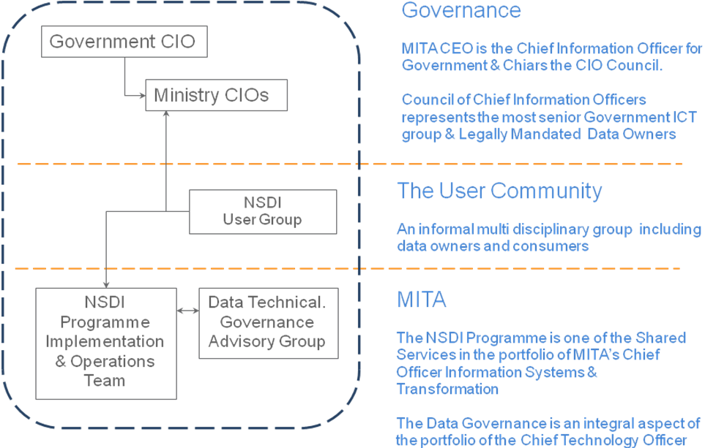

Comments on the monitoring and reporting process
A formal process for institutionalising monitoring and reporting amongst the stakeholders is yet to be articulated and implemented.

Quality Assurance (Art. 12.2.)

Quality assurance procedures
Detailed considerations of quality assurance are at the preliminary stages and significant action has not yet been identified or planned.

The initial objectives of achieving a comprehensive inventory of datasets and the associated metadata has yet to be evolved to considerations of quality assurance in the delivery of INSPIRE services.

Analysis of quality assurance problems
At this stage no specific analysis can be reported.

Measures taken to improve the quality assurance
Appropriate measures will be identified based on the eventual outcomes of the quality assurance analysis.

Quality certification mechanisms
MITA maintains ISO 9000 accreditation as well as adopting ITIL service methodologies and PRINCE 2 Project methodologies.

These institutional disciplines will leveraged to embed quality management procedures in the implementation o the Directive.

Functioning and coordination of the infrastructure (Art.13)

General overview description of the SDI

MITA is still in the formative stages of planning the SDI in detail. Further work is required to reach a stage of public policy statements beyond the binding legal instruments implemented through the transposition of the Directive.

INSPIRE Stakeholders
The current active stakeholders contributing to the implementation of the infrastructure for spatial information are currently limited to MITA and MEPA. MITA is also providing the necessary guidance and infrastructure for the legally mandated bodies responsible for the principal data themes in Annex 1 and Annex 2.

Role of the various stakeholders
The level of stakeholder engagement is still at its initial stages, and is expected to accelerate once the Geoportal services provide additional facilitation for reuse.

Nonetheless, an indicative framework of current stakeholders contributing to the SDI, and the associated indication of responsibilities as primary (P) and supporting (S) is provided below.

Activity | MITA  (Governance Infra-strucutre) | MEPA (Mapping Function) | Govt. Data providers inc. MEPA | Private Sector
Provides the framework for governing the NSDI across the spectrum of national ICT | P
Outlines the business model for financing the NSDI | P | S | S
Retains the expertise and main processes for provisioning the underlying datasets (Base Map) |  | P |  | S
Provides the infrastructure for deploying NSDI data within Government and the wider user community | P | S | S | S
Provides the technical EU liaison to assure compliance with the various implementing rules of the INSPIRE directive | P | S
Provides the technical input to the execution INSPIRE directive depending on the specific data or functional theme. | P | P | P
Contributes datasets to the NSDI |  | P | P | S
Identifies and assures synergy and reuse of data across Government | P | S | P
Migrates existing datasets to standards set by INSPIRE | S | P | P | S
Provides added value services based on published data themes and services |  |  |  | P
Re-engineers business processes to ensure data is collected in the most appropriate manner and re-use facilitated | P |  | P | S

Measures taken to facilitate sharing
At this stage a number of technical measures to ensure convergence in ICT solutions across Government are being implemented. These will enable the practical implementation of data sharing across public institutions.

Stakeholder cooperation
A detailed framework articulating the stakeholder cooperation specifically related to the implementation of the Directive is not yet in place. The current provisions are based on the remit of the MITA to provide the central function of CIO to Government.

Access to services through the INSPIRE Geoportal
A single national geoportal which implements the full provisions of INSPIRE is still not available. Procurement procedures are underway to contract the implementation of the portal. The primary existing geoportal provides access to environmental data and can be found at www.mepa.org.mt.

Usage of the infrastructure for spatial information (Art.14)

Use of spatial data services in the SDI
Within the scope of the report, a number of view services are available from the MEPA geoportal accessible from www.mepa.org.mt. These view services are open to public access free of charge and include datasets relating to the spatial delineation of Building development applications as well as protected areas and associated data. The use of these view services is widespread although no clear metrics are available.

Use of the spatial datasets
Spatial datasets are widely used by the Malta Environment and Planning Authority. In particular, widely accessible datasets on a range of Annex 1 themes, as well as various themes relating to protected areas are commonly accessible and used across the environmental policy making sector.

A number of data themes are utilised by government agencies and utilities to provide the base context for GIS implementations, predominantly in land registration, management of government land assets, integrated agriculture control, utilities and transport amongst others.

Use of the SDI by the general public
The general public has access to view services from the MEPA geoportal accessible from www.mepa.org.mt. The use of these services by the general public is evidenced by the number of online transactions for downloading site maps.

Cross-border usage
Specific examples of cross border usage are limited to the submission of information inherent in a number of EU reporting requirements and the exchange of information in the context of a number of international cross border projects.

Use of transformation services
In general, spatial information is accessed directly on ‘local’ systems or databases. There are no specific examples of network transformation services in use during the reporting period.

Data sharing arrangements (Art.15)

Data sharing arrangements between public authorities
The principle datasets are available for reuse and are currently made available by the relevant public authority. The evolution of the SDI will entail a consolidation of the approach to data reuse for all the data themes under the Directive and the central provisioning of this data by MITA.

Data sharing arrangements between public authorities and Community institutions and bodies
These arrangements are generally driven by reporting requirements. Limited wider re-use of community or national datasets between public bodies or community institutions has been identified.

Barriers to the sharing and the actions taken to overcome them
In general the main environmental datasets are not limited by significant barriers to sharing or reuse. The main challenges relate to the reuse of base mapping and other themes where there is no clear business model to the continued maintenance and evolution of the dataset.

Over the past years, MEPA have simplified the general approach to license arrangements for reuse of topographic data. MEPA maintains a partial cost recovery approach through which major users of map data are charged for use of the data. All minor distribution is charged at marginal cost levels.

Production and maintenance of thematic datasets are largely funded directly from Government, particularly where national coverage is required.

Costs resulting from implementing INSPIRE Directive
At this stage significant investments are still at the planning stage and to date no cost structures or metrics have been actively measured.

Benefits observed
Actual benefit realisation planning has not been specified at this early stage. Nonetheless, the transposition of the Inspire Directive and the strong policy leadership and synergy with the National ICT vision is already diffusing the barriers to sharing and reuse across Government.

Conclusions
In general, specific progress in formalising an SDI for Malta remains at the inception stage, with the main achievements being the enabling legislative instrument and the clear assignment of a competent authority.

Nonetheless, the central provisioning ability within the public sector and the role of the National ICT Agency as the competent authority is set to make significant changes in operational alignment of the main Government ICT solutions in a manner which leverages the benefit of a centrally provisioned SDI.

Annexes

List of organisations – names and contact details

Matthew Gatt Malta Information Technology Agency
Stefan Spiteri Malta Information Technology Agency

Contact details: euaffairs@mita.gov.mt

List of references for the compilation of the report
Smart Island Strategy http://www.mitc.gov.mt
MITA Strategic Plan http://www.mita.gov.mt
LN 339/09 Infrastructure for Spatial Information Regulations, 2009 http://docs.justice.gov.mt/lom/Legislation/English/SubLeg/356/23.pdf

